I can complete 13 Activities in this guide to:

- Explain how governments can use AI to make practical decisions.
- Analyze how a person’s lived experience is affected by AI-based decision making systems.

- Create an infographic to illustrate how AI systems affect livelihoods.

13 Activities start now!
1/13 | ✏️Write your name:

2/13 | ✏️Your class period:

3/13 | 🔥Warm Up - How do governments make decisions, like how long someone goes to jail, who gets food assistance, and who deserves free community college? Write at least ONE (1) complete sentence in the space below.

4/13 | 👀Read the definition of an automated decision system:  A computer program that makes decisions based on data and rules and aims to replace human decision-making.

5/13 | 💻Visit aiedu.org/ai-in-five to read the definition and interesting examples of AI.    Scan the QR Code to visit AI in Five  🔗aiedu.org/ai-in-five

6/13 | 👁️👁️Experience AI through someone else’s eyes  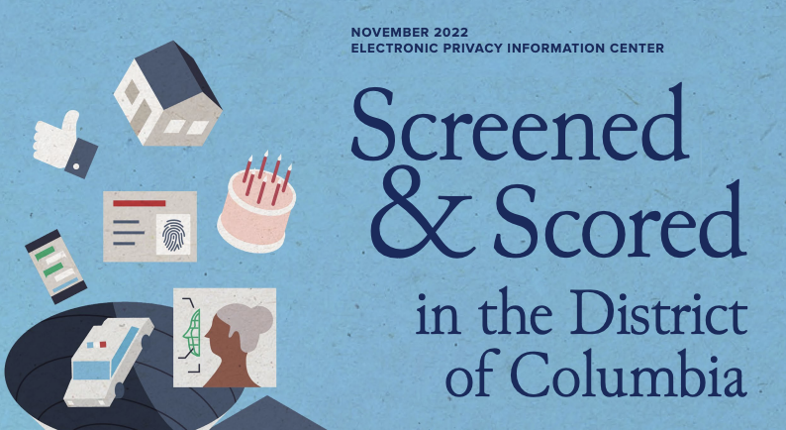    Throughout this project, you’ll be referencing a report called Screened & Scored in Washington, D.C., which was written by the Electronic Privacy Information Center.  - Visit tinyurl.com/screenedandscored OR scan the QR code to view the Screened & Scored in Washington, D.C. report.  - Choose ONE (1) person to read about:  - Juan Hernandez (pages 6-10)  - CeeCee Montgomery (pages 31-35)  As you read, answer the questions below.

7/13 | ✏️How was the person’s experience POSITIVELY affected by AI?

8/13 | ✏️How was the person’s experience NEGATIVELY affected by AI?

9/13 | ✏️What do you think would change about their experience if the AI was never used? Write at least ONE (1) complete sentence in the space below.

10/13 | 🔍Examine AI systems  - GO TO pages 12-14 in the Screened & Scored report which has a table of AIs used in Washington, D.C. The link to the report is on Page 2, activity 5.  - Examine each system and consider who uses it and why.  - Choose two systems that interest you. In the activities below, explain who would be affected by the system, what benefits it could have, and what could go wrong.

11/13 | ✏️Name of System 1:  What kinds of people would System 1 affect?  If System 1 worked perfectly, how would it benefit this person?  If System 1 messed up, what harm could it cause?

12/13 | ✏️Name of System 2:  What kinds of people would System 2 affect?  If System 2 worked perfectly, how would it benefit this person?  If System 2 messed up, what harm could it cause?

💯 Keep up the great work! There’s more on the next page …
▼
13/13 | 📜Create a Public Service Announcement (PSA)  The goal of this PSA is to raise awareness among citizens of D.C. about how AI systems are used in their community.  - Choose one of the two imaginary people below to focus on:  - Choose 5 systems from the Screened & Scored report that you think might affect their life. The link to the report is on Page 2, activity 5.  - Create a physical or virtual infographic (on paper or in Google Slides or Canva) explaining to them how these systems might affect them. Put the person at the center of your infographic and help readers visualize how these systems affect their lives.  - Make a conclusion at the bottom of your poster: how are people’s lives affected by these systems in Washington, D.C.?  Tips & tricks  - Make your poster visual: show how the person would be affected  - Use any statistics and information you can find in the report to support your ideas
   | 
  Hector, an 18-year-old senior at a local high school who is excited to graduate. He moved out this year because he wanted to be on his own. He’s crashing with a friend right now but is looking for his own apartment. He did get in trouble with the law a few times freshman year, and spent a bit of time in juvenile detention, but all that is behind him. | Celine, a 41-year-old business owner who owns two buildings downtown. She got unemployment benefits before starting her business last year. She lives in an area with gang activity, so she tries to keep her head down. She injured her back in a car accident recently and has a prescription for pain medication.
🤿When you’re done, dive deeper! (Optional) Check out the table below of automated decision systems used in New York City. What similarities and differences do you notice?
Automated Decision Systems in New York City:
🔗tinyurl.com/nycadschart

